**DAILY ONLINE ACTIVITIES SUMMARY**

|  |  |  |  |  |  |  |  |  |
| --- | --- | --- | --- | --- | --- | --- | --- | --- |
| **Date:** | 10-07-2020 | | | | | **Name:** | Shreetal kalabandi | |
| **Sem & Sec** | 6th and B | | | | | **USN:** | 4AL17CS091 | |
| **Online Test Summary** | | | | | | | | |
| **Subject** | | ______ | | | | | | |
| **Max. Marks** | | ____ | | **Score** | | | ____ | |
| **Certification Course Summary** | | | | | | | | |
| **Course** |  | | | | | | | |
| **Certificate Provider** | | |  | | **Duration** | | |  |
| **Coding Challenges** | | | | | | | | |
| **Problem Statement:** GIVEN 1 PROBLEMS | | | | | | | | |
| **Status:** Completed | | | | | | | | |
| **Uploaded the report in Github** | | | | | Yes | | | |
| **If yes Repository name** | | | | | <https://github.com/Shreetal/Dailyreport>  <https://github.com/Shreetal/online-coding> | | | |
| **Uploaded the report in slack** | | | | | Yes, I uploaded the report in slack | | | |

**SNAPSHOT OF ONLINE CODING:**

**PYTHON PROGRAM 1:**

**Python program for BubbleSort.**

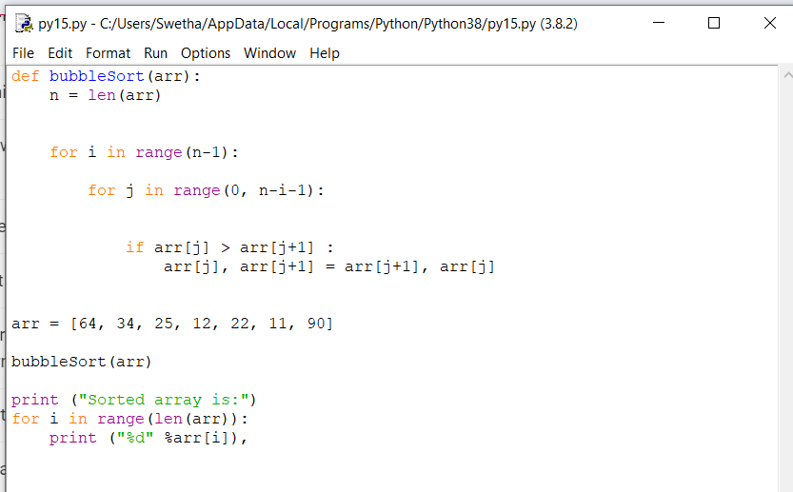

**OUTPUT:**

